**Celebration of Learning**

We will teach the younger children about fire safety and record our diary entries for our parents to watch at home.

**Music**

We will find out about historical songs and chants connected to the Great Fire of London. We will explore dynamics, pitch and tempo. Finally, we will use all we have learned to create a simple 4-part music and movement composition, inspired by the Great Fire.

**Key Questions …**

Do all homes look like mine?

I wonder which factors made The Great Fire of London so disastrous.

ACTIVATE CURIOSITY DISCUSS & DISCOVER LET’S DO IT! DIG DEEPER SHARE, CELEBRATE & REFLECT

Homes and Houses

**Activate curiosity**

We will look at images from The Great Fire of London and create our own collages of the fire.

Do we have any questions?

What do you wonder about the images?

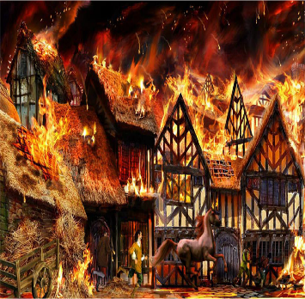

**Vocabulary**

Human, physical, city, landmark, River Thames, sources, similarity, difference, factors

**Science**

Marvellous Materials:

We will discuss, identify, label and record materials in the classroom. We will learn to distinguish between an object and the material from which it is made. We will also consider how the properties of materials make them suitable for their purpose.

**Geography**

Where is London? How has it changed over time?

What are it’s physical and human features? What are the weather patterns like? Are these similar to where we live? How are they different?

**History**

We will create our own timelines of the Great Fire of London.

We will be able to discuss the significance of the Great Fire of London and make up our minds as to who was to blame for the fire.

We will be able to look at and discuss a range of historical sources regarding the Great Fire ofLondon.

**English**

We will play in role of ‘Samuel Pepys’ and write a diary just like his. We will create freeze frames and use our five senses to imagine what it was like to be in London whilst the Great Fire was breaking out.

**We will be practicing our performance skills for our winter Snowman Musical!**

Year 1 and 2 Dragonflies

Autumn Term 2

2021

**RE**

What does it mean to belong to a faith community?

**Maths**

We will focus on addition and subtraction, money, multiplication, and division.