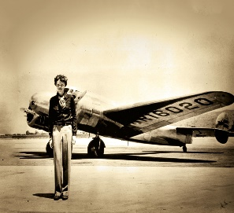

**Celebration of Learning**

We will test the kites that we have made – how good are they at flying? We will evaluate their effectiveness and bring together everything that we have learnt.

**Key Questions …**

Who was Amelia Earhart and why is she remembered?

ACTIVATE CURIOSITY DISCUSS & DISCOVER LET’S DO IT! DIG DEEPER SHARE, CELEBRATE & REFLECT

Up, Up and

Away!

**Activate curiosity**

We will begin our topic with a parachute experiment in which, we will see which team can safely deliver a boiled egg to the ground without it cracking. How can we slow the egg down? Which materials will make the best parachute to glide the egg to safety?

**Science**

In science we will be exploring the uses of everyday materials. We will learn to:

Identify and compare the suitability of a variety of everyday materials, including wood, metal, plastic, glass, brick, rock, paper and cardboard for particular uses

Find out how the shapes of solid objects made from some materials can be changed by squashing, bending, twisting, and stretching.

**Maths**

Year 1 will focus on:

* Length and height
* Volume and weight

Year 2 will focus on:

* Statistics
* Fractions

**Vocabulary**

Chronological order, gravity, evaluate/ critique, forces, North, East, South, West, significance, difference, similarity, timeline.

**PE**

In PE we will be developing our teamwork skills, applying them to several games.

**History**

In history we will look at the chronology of flight and create a class timeline to show this. We will also look at the Wright Brothers and their contribution towards building planes and the change in flight. We’ll also look at the significance of Amelia Earhart and compare her achievements to Jean Batten’s

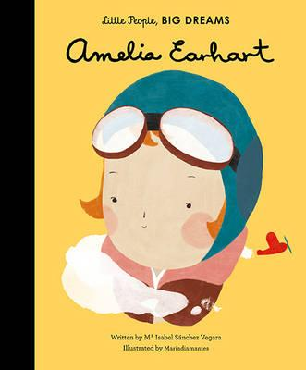

**Guided reading**

Our class reader will be ‘The Owl who was Afraid of the Dark’. We will explore how to make inferences, how to find key details and explain key vocabulary in our weekly guided readingsessions.

**English**

In our writing sessions, we learn about the structure of a biography as well as Amelia Earhart’s life. When we have gathered information and created a plan, we will use subheadings, titles, pictures, and captions to create a wonderful, factual biography piece of writing.

**RE**

In RE we will use our learning to try to answer the question ‘How should we care for the world and for others and why does it ‘matter?

Year 1 and 2 Dragonflies

Spring term 2

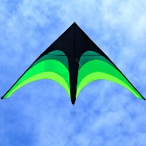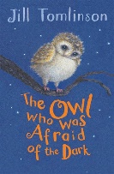

**Design and Technology**

We will be designing, making, and evaluating our own kites in D&T this half term.

**Geography**

In Geography, we will practice using simple compass directions including North, East, South and West.