Dragonflies’ Home Learning – Summer 1

Date | Rapid maths – use the methods that we have learnt to quickly answer: | Phonics Bug | Weekly
29th April | 2 x 5 =  13 + 5 =  3 + 16 =  25 + 9 =  26 + 48 =  32 – 5 =  37 – 12 =  28 – 19 =  4 x 10 =  7 x 2 =  6 x 2 =  12 ÷ 2 =  10 ÷ 2 =  6 ÷ 2 =  20 ÷ 2 =  30 ÷ 10 =  50 ÷ 10 =  100 ÷ 10= | - Read a book on phonics bug  - Play one game on phonics bug that is linked to our learning this week. | Practice my spelling list  Times tables rockstars or numbots  Have I read to an adult 3 times?
6th May | 3 x 5 =  26 + 5 =  4 + 20 =  13 + 9 =  65 + 18 =  26 – 5 =  89 – 12 =  35 – 17 =  5 x 10 =  9 x 2 =  8 x 2 =  10 ÷ 2 =  16 ÷ 2 =  2 ÷ 2 =  60 ÷ 2 =  60 ÷ 10 =  80 ÷ 10 =  90 ÷ 10= | - Read a book on phonics bug  - Play one game on phonics bug that is linked to our learning this week. | Practice my spelling list  Times tables rockstars or numbots  Have I read to an adult 3 times?
13th May | 5 x 5 =  56 + 5 =  9 + 30 =  23 + 9 =  24 + 14 =  16 – 5 =  65 – 12 =  23 – 14 =  6 x 10 =  9 x 2 =  8 x 2 =  18 ÷ 2 =  14 ÷ 2 =  4 ÷ 2 =  20 ÷ 2 =  10 ÷ 10 =  30 ÷ 10 =  70 ÷ 10= | - Read a book on phonics bug  - Play one game on phonics bug that is linked to our learning this week. | Practice my spelling list  Times tables rockstars or numbots  Have I read to an adult 3 times?
20th May | 6 x 5 =  15 + 5 =  8 + 22 =  4 + 8 =  13 + 11 =  11 – 5 =  47 – 12 =  36 – 17 =  2 x 10 =  8 x 2 =  7 x 2 =  22 ÷ 2 =  16 ÷ 2 =  14 ÷ 2 =  100 ÷ 2 =  80 ÷ 10 =  40 ÷ 10 =  90 ÷ 10= | - Read a book on phonics bug  - Play one game on phonics bug that is linked to our learning this week. | Practice my spelling list  Times tables rockstars or numbots  Have I read to an adult 3 times?
27th May | 5 x 5 =  25 + 5 =  5 + …… = 20  6 + 18 =  17 + 14 =  19 – 8 =  34 – 25 =  41 – 13 =  8 x 10 =  9 x 2 =  11 x 2 =  22 ÷ 2 =  24 ÷ 2 =  6 ÷ 2 =  18 ÷ 2 =  20 ÷ 10 =  70 ÷ 10 =  60 ÷ 10= | - Read a book on phonics bug  - Play one game on phonics bug that is linked to our learning this week. | Practice my spelling list  Times tables rockstars or numbots  Have I read to an adult 3 times?

Learning Enquiry tasks:
Please choose one or more of these tasks to complete based on our ‘Amazing Africa’ learning enquiry.
This half term’s writing task:
Can you write a non-chronological report about Meerkats?
You could research lots of information and write sentences using different subheadings. Your subheadings could be:
Where do Meerkats live?
What do meerkats eat?
The lifecycle of a meerkat
How do Meerkats adapt to their habitats?
Remember to include:
- Super vocabulary - conjunctions to extend
- Interesting descriptions - adverbs
- Subheadings - Title - Pictures and captions

- Please make sure you can recall all of these phase 5 sounds – practice them daily if you find any of them difficult to remember.
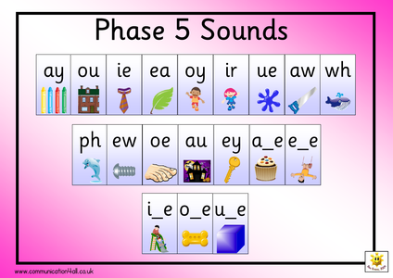
- Please see the spelling list for years 1 and 2 – it is important that all children know how to read and spell these words by the end of KS1.

