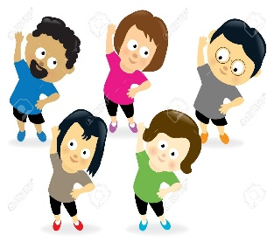

**Celebration of Learning**

We will make a healthy meal to take home, with a description of the different food groups that are inside and why they are good for us.

**Key Questions …**

How can we be the best we can be by looking after our own health?

ACTIVATE CURIOSITY DISCUSS & DISCOVER LET’S DO IT! DIG DEEPER SHARE, CELEBRATE & REFLECT

Healthy

Me!

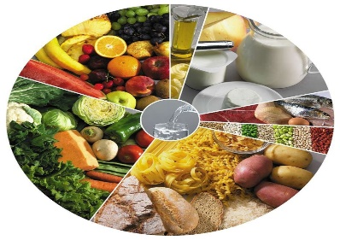

**Vocabulary**

Compare, contrast, Crimean war, battlefields, barracks, conditions, appalling, contribution, achievement, carbohydrate, fibre, dairy

**Activate curiosity**

We will take a look at images of hospitals in the past so that we can develop our own thoughts and questions.

We will also explore the amount of sugar in various foods to get us thinking about healthy alternative choices.

**PE**

In PE we will be having a specialist dance teacher to teach us some contemporary dance.

**Science**

In science we will:

* Notice that animals, including humans, have offspring which grow into adults
* Find out about and describe the basic needs of animals, including humans, for survival (water, food and air)
* Describe the importance for humans of exercise, eating the right amounts of different types of food, and hygiene

**Maths**

Year 1 will focus on: addition and subtraction, place value within 50, weight and height, capacity, and volume.

Year 2 will focus on: money, multiplication and division and statistics

**History**

In history we will explore how Florence Nightingale contributed to national and international achievements. We will look at how Florence changed the world of nursing for the better and the children will be able to compare what hospitals were like then and now. They will learn about the impact that Florence had during her life and how this moved on the way that we keep ourselves and each other healthy.

**Spanish**

In Spanish we will be learning vocabulary about the seaside!

**English**

During our English lessons, we will be writing our own versions of Little Red Riding Hood. These will help us to develop skills such as: writing commas in a list, using past tense verbs with consistency and using a range of sentence types including: command, statement, exclamation and question.

Year 1 and 2 Dragonflies

Spring term 1

**RE**

Who is Jewish and how do they live?

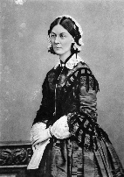

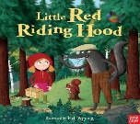

**Geography**

Where did Florence Nightingale help the soldiers?

Can we find where she worked on a map?