**Celebration of Learning**

We will be having a visit from the queen where we will share our guides to London with her

ACTIVATE CURIOSITY DISCUSS & DISCOVER LET’S DO IT! DIG DEEPER SHARE, CELEBRATE & REFLECT

Please look after this bear!

**Music**

We will be creating our own piece of music based on a scene from the film Paddington! We will be creating, selecting, and blending sounds to make a class piece.

**Activate curiosity**

We’re going on a bear hunt! Let’s see if we can find the 8 different species of bear that are hidden around the school grounds.

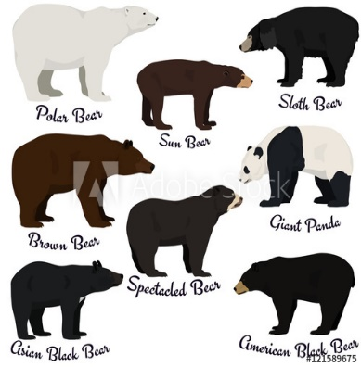

**Vocabulary**

Landmark, physical, human, location, habitat, capital cities, rivers, cities, town, sea, ocean, directions

**Science**

Living things and their habitats:

What do animals need to survive? How can we help a bear to survive?

We will be looking at the habitats that various bears live in from around the world to answer the question ‘Do all bears need the same things?’

**Geography**

Which bears live where?

We will be looking at world maps and identifying the various places that different bears live. We will be identifying the UK on a map, finding the four countries, and naming the capital cities, rivers and seas that surround us.

**English**

We will use the text ‘Katie in London to find out about the landmarks that can be found there. We will be writing our own guides about the best places to visit when on a trip to London. We will be able to include facts, fabulous vocabulary, and a range of conjunctions to join our ideas in sentences together.

**Art & Design**

This half term we will focus on our drawing techniques. We will be observing and drawing thinking carefully about line, shape and space**.**

**English**

We will begin by writing our own instructions for how to make Paddington’s favourite sandwiches – marmalade!

We will learn how to sequence our ideas, use bossy verbs (imperatives) and interesting adjectives.

**RE**

We will be looking at Creation and thinking about what we are grateful for in the world.

Year 1 and 2 Dragonflies

Autumn Term 1

2021

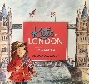

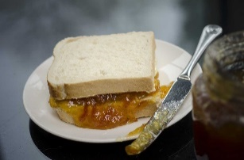

**Maths**

Number: place value, addition, and subtraction