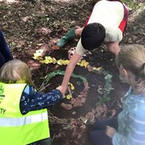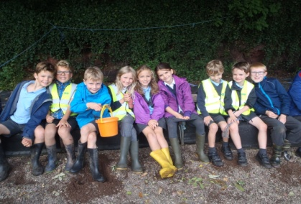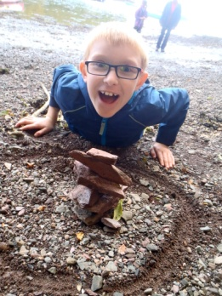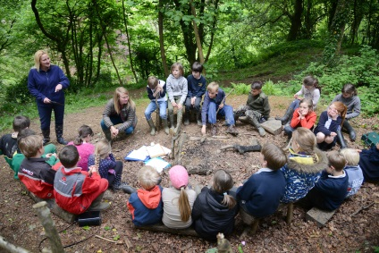

**Key Priority 6**

**Recruitment and Retention**

Work Strategically to be full for entry in to Pre-school and Reception and full in all year groups.

**Key Priority 5**

**SMSC**

. **To review the provision of PSHE to ensure children are being prepared for life in the modern world and can make informed choices to guarantee their safety.**

**Key Priority 4**

**Teaching and Learning**

. **To improve ICT facilities to enable children to become digitally literate and use ICT as a creative tool.**

**Key Priority 3**

**Teaching and Learning**

**To develop a new enriching curriculum for the new class structure to provide exciting and memorable learning experiences and so improve pupil outcomes**

**Key Priority 2**

**Outcomes for Pupils**

**To continue to improve writing across the school and increase the number of children writing at Greater Depth**

**Key Priority 1**

**Outcomes of Pupils**

**Build Learning Power across the school to enable children to become more efficient and independent learners and so improve pupil outcomes**

**STOKE GABRIEL KEY IMPROVEMENT PRIORITIES 2017- 2018**