Dragonflies’ spellings Summer 2 week 7 – Common Exception words
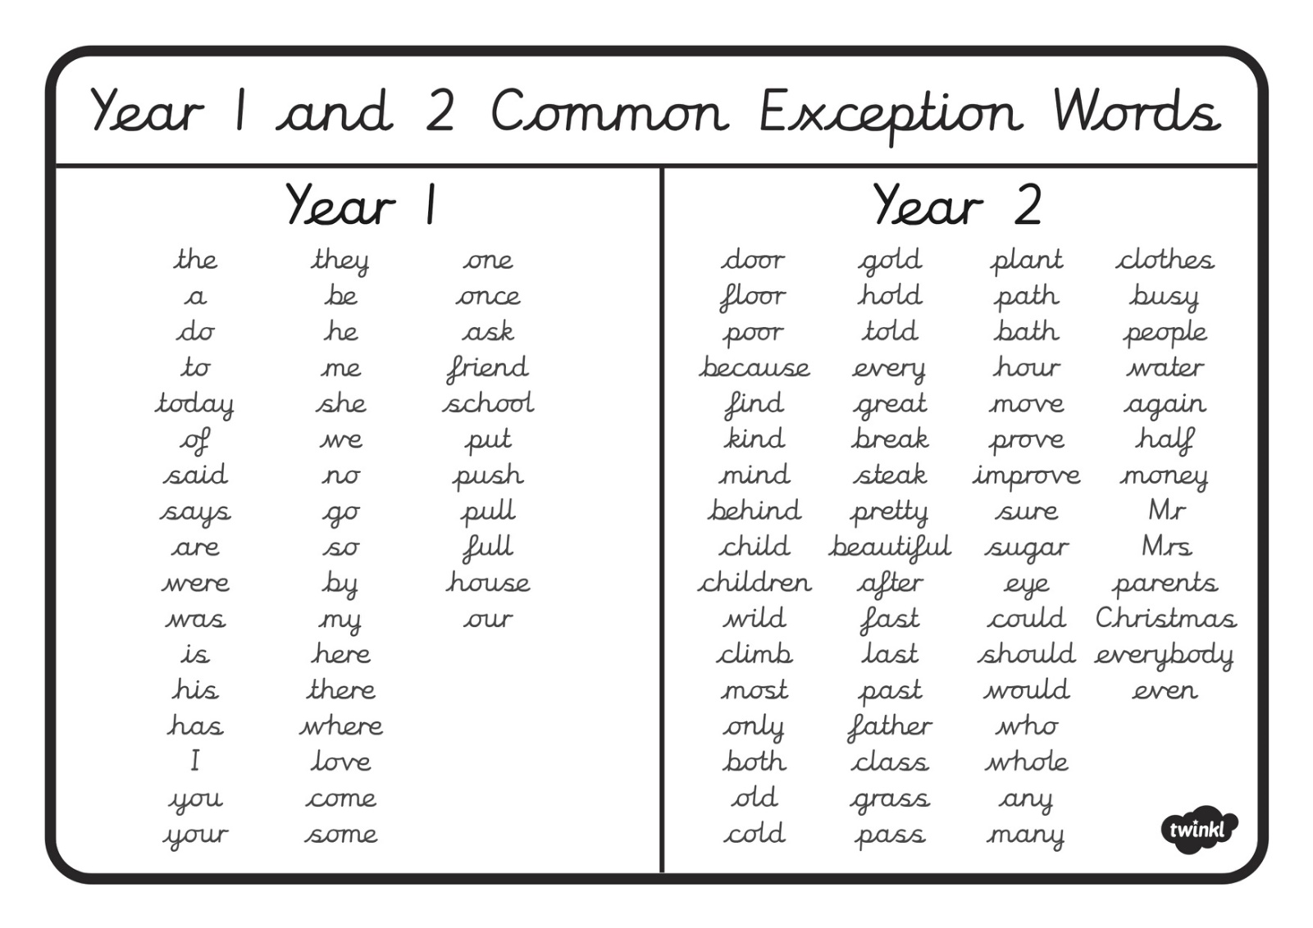
Spelling challenge on: Friday 22nd July
Please choose and practice ten of the common exception words from above that you are still finding tricky to spell. Practice these and we will do an individual spelling challenge on Friday 22nd July.
Word | look | Cover and write | check

