PSHE
Our theme this half term is ‘Being me in my World.’ How does attitude affect those around you and determine how you feel/interact with the world?

Science
Our science topic for the first half term will be ‘rocks’. We will be learning to compare and group together different kinds of rocks on the basis of their appearance and simple physical properties. We will work on describing (in simple terms) how fossils are formed when things that have lived are trapped within rock. Finally, we will recognise that soils are made from rocks and organic matter.

.

Maths
Both year groups will be focusing on place value. Year 3 will develop their understanding of numbers with digits, while Year 4 will extend to 5-digit numbers. Pupils will be improving their fluency using the four operations: adding, subtracting, multiplying, and dividing.

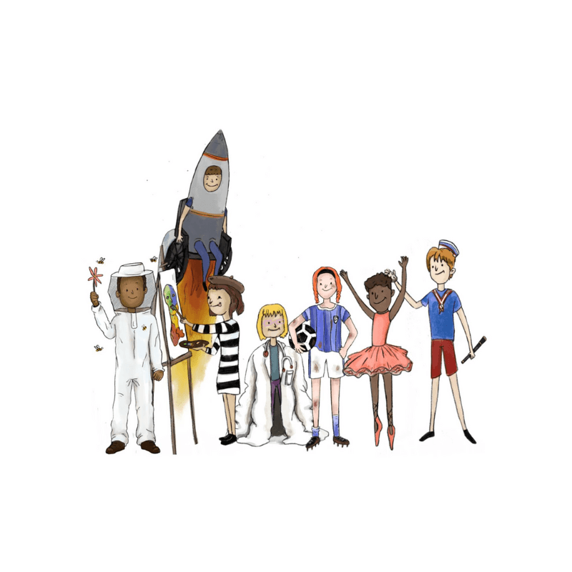

RE
During our RE sessions, we will explore the question ‘What do Hindus believe God is like?’ We will be able to make simple links between beliefs about God and how Hindus live as well as learning to identify some different ways in which Hindus worship.

Geography
‘Why do some earthquakes cause more damage than others?’ This enquiry introduces pupils to some key aspects of physical geography. We will be looking at one of the major outcomes of tectonic activity in the world - earthquakes.

PE
PE kits to be worn on Thursdays and Fridays please!

Art
Our children will be focusing on the skill of drawing so that we can create sequenced imagery to tell stories.

Languages
Our topic will be ‘Welcome to Spain’. We will be learning to build sentences to introduce ourselves and say where we live.

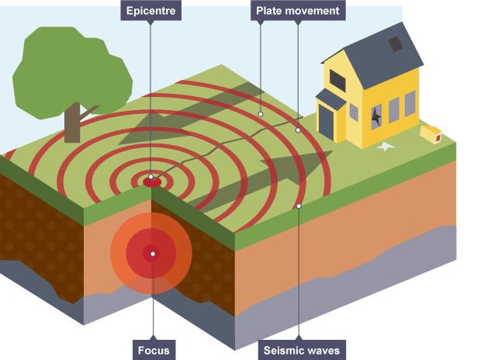
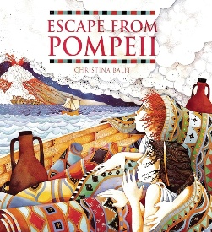
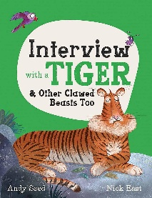
English
Pupils will be inspired by Balit’s Escape from Pompeii, to rewrite an account from a character of their choice, using first person, commas after fronted adverbials, prepositions and carefully chosen vocabulary to build tension. The second unit will be inspired by Interview with a Tiger, by Seed and East, to write an informative and engaging non-fiction text.

a



Computing
We will be learning about Computer systems and networks – developing an understanding of how computers process information.
Music
In music, we will be taking part in whole-class instrumental lessons using tuned percussion. This South Africa-themed unit develops pupils’ rhythmic, singing and notation skills.

Butterflies Planning Map – Autumn 1

Butterflies – Autumn 1 home learning
Daily | Weekly | Termly
Read  The most important activity you can do is read. Ideally, 20 minutes or more, but even if it’s just a few pages, you will expand your vocabulary and learn something new. Carry a book; you never know when you might get the opportunity!    AR quiz at home, or at school.  QR:   | - Practice your weekly spellings. Tests are on Fridays.  - Practice your times tables – this could be enhanced using ‘times tables rockstars’.  Multiplication knowledge underpins lots of number knowledge, which will accelerate your progress in maths! | Homework Project  Homework: Using supervised online research, pupils will produce a short report that locates the area known as the Pacific Ring of Fire, using hand drawn maps, which identifies why so many volcanoes and earthquakes occur here.  This can take the form of their choice, such as a poster or leaflet which is colourful and ready for display.  

