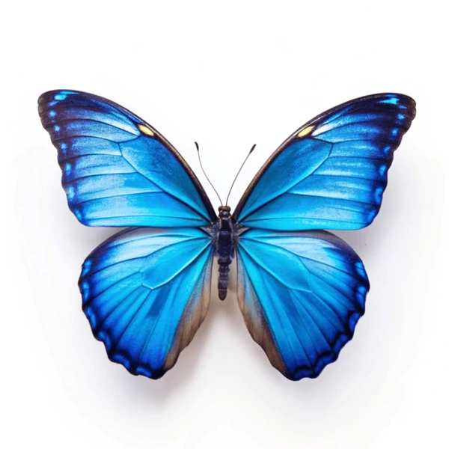
Summer 2 Curriculum Overview 2026

Butterflies’ class
Maths
In Maths, children will be exploring money, shape and statistics. This includes converting pounds and pence, comparing amounts and finding change, learning about angles and polygons, and representing information on different types of graphs and charts.
Science
In Science, we will be exploring sound. This includes how sounds are made, how they travel, and how pitch and volume are affected by different materials and distance.
PSHE
In PSHE, our topic is Changing Me. We will be exploring body changes and the reproductive system, as well as feelings around change. We will also look at growing up and responsibilities, and emotions linked to moving into a new year group.
Humanities
In Humanities, we will be exploring the Iron Age. We will investigate how artefacts help us understand life in Iron Age Britain, including changes from the Stone Age to the Iron Age. We will use enquiry skills to explore hill forts, roundhouses and the life of Boudica
Art, design and technology
In Design technology, we will design and make a 3D structure to package a healthy snack. We will explore 3D shapes and nets, evaluate existing designs and create design criteria to guide our work.
English
In English, we will build on sentence structure through traditional tales, using past tense, speech, adverbs, subordinate clauses and expanded noun phrases. We will also explore the Beachcomber, writing poems in different forms such as lists and free verse.
RE
In RE, we will be exploring how and why people try to make the world a better place. We will learn about ideas of right and wrong and explore figures of positive change. We will also look at how religious and non-religious beliefs inspire people to help others.
PE
In PE, we will be preparing for Sports Day. We will develop our athletics skills, including running, jumping and throwing. We will practise techniques to improve speed, strength and accuracy.
Computing
In Computing, we will be learning about computational thinking and algorithm design. We will break problems down, focus on the important information, look for patterns and create clear step-by-step instructions. We will use these skills to code, test and improve our work
Languages
In Spanish, we will be looking at a travel diary of a journey around Latin America. We will locate Spanish-speaking countries and use key vocabulary to say where we are going and how we are travelling. We will also learn the days of the week and write simple sentences.
Music
In Music, we will be exploring carnival sounds and Latin American music. We will perform a salsa-style song and play from staff notation. We will also create a mini carnival performance using song, dance, and tuned and untuned instruments.
Summer2 Homework 2026
Butterflies’ class
Daily  Please read your book each day – even if it is just a few pages. This is the most important activity you can do!  - Bug Club books need to be read at least twice for fluency.  - If you are on Accelerated reader, you can quiz on this website either at home or when you come to school the next morning:  https://global-zone61.renaissancego.com/welcomeportal/2236638  Or scan the QR code. | 
Each week  - Practice your weekly spelling list ready for a spelling check each Friday  - Times tables rockstars (this is particularly important for our year 4s who will be taking the government times tables check this term). We will have a weekly times-tables check each Monday.  Year 4’s may wish to practice multiplication tables speed on the following web-links:  https://urbrainy.com/mtc/test  https://www.timestables.co.uk/multiplication-tables-check/  https://mathsframe.co.uk/en/resources/resource/477/Multiplication-Tables-Check | 
Topic:  RE: Figures of positive change  In RE, we will be exploring how and why people try to make the world a better place.  Your task is to research a person who has made a positive change in the world.  - Choose someone such as Martin Luther King Jr. , Malala Yousafzai, David Attenborough or Mother Teresa.  - Research their life and explain what they did in the past and how their actions changed the world.  - Describe how their work still affects people, animals, or the planet today.  - Create a poster, fact file, leaflet or PowerPoint, include pictures and interesting facts.  - Present your work neatly and explain why you chose this person. |   