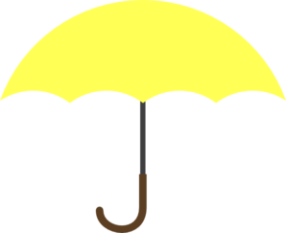

**Literacy**

* Recognising and writing your name
* Mark making and giving meaning to the marks made
* Phonics – Phase 1 and Phase 2
* Listening and responding to a variety of stories
* Focus book – ‘Here We Are’

***Ladybirds Class – 2020/2021***

***Autumn 1-***

***Here We Are!***

**Characteristics of Effective Learning**

**Prime areas**

**Umbrella Narratives:**

Here We Are

Me on the map

We’re going on a bear hunt

Owl babies

Out and about

Rosie’s walk

**Specific areas**

**Final event:**

**Children to create their own map of our locality**

**Whole School Display?**

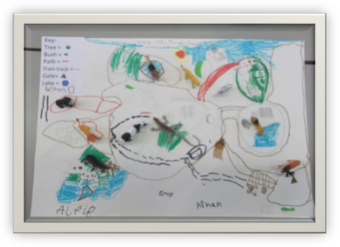

**HOOK:**

***Creating and thinking critically***

*-Having their own ideas*

*-Making links*

*-Choosing ways to do things*

**Key vocabulary**

Earth, globe, space, moon, stars, sun, solar system, land, sea, mountains, volcano, hills, fields, grasslands, forests, deserts, palm trees, ponds, cliffs, river, icebergs, snow, wind, clouds, rain, rainbows, storm clouds, lightning, animals, head, brain, arms, belly, legs, heart, lungs, bones, nails, hair, countryside, city

**Personal Social and Emotional Development**

* Class/school rules
* Turn-taking
* Kindness – learning how to socialise and care for the needs of others
* Achievosaurs – ‘tryatops’

**Expressive Arts and Design**

* Self portraits
* Nature art – exploring our environment
* Create small world scenarios
* Record experiences through drawing, painting, model making

**Physical Development**

* PE – spatial awareness and functional movement
* Outdoor learning
* Self-care – how do we keep ourselves safe and healthy
* Fine motor skills – dough disco/funky fingers
* Gross motor skills – crossing midline
* Changing for PE
* Personal hygiene – hand washing

***Active learning***

*-Being involved and concentrating*

*-Keep on trying*

*-Enjoy achieving what they set out to do*

**Mathematics**

* Match and sort
* Compare amounts
* Compare size, mass and capacity
* Explore pattern
* Key times of day, class routines
* Where do things belong?
* Positional language

***Playing and exploring***

*-Finding out and exploring*

*-Playing with what they know*

*-Being willing to have a go*

**Understanding the World**

* RE - Being special: Where do we belong?
* Google Earth – locate our school, identify UK, Devon, the river Dart, Stoke Gabriel
* Our Solar System
* Create maps of our local area
* Beebots

**Communication and Language**

* Sharing our thoughts and questions
* Listening to others
* Key vocabulary – see list
* Questions – Where is ‘here’? What is it like ‘here’?

Outdoor Learning -

**DISCREET**

Show and Tell -