We would love for your child to be able to complete at least three of these activities between now and half term. We believe that challenge is an extremely important part of learning. This is reflected in the home learning grid. Feel free to choose the challenges that you would like to extend learning in. Please see separate spellings for each week’s spelling challenge.
Dragonflies Home Learning Grid – Autumn 1
Week | Maths | English | Learning Enquiry
6.9.21 | Sorting objects  Challenge: Choose a group of objects that you have at home (eg. Toys, games, food items), can you sort them? How many groups are there? How many different ways can you arrange them into groups? | We are writing instructions in school at the moment. Can you write your own set of instructions at home? It could be instructions about how to make your favourite dinner, to play your favourite game, to make a tasty snack … anything you like!  Remember to include:  - A title  - A short introduction  - Bossy verbs eg. Put, place, pour, tickle.  - Numbered steps  I can’t wait to read them!  Challenge: Can you add in a range of adverbs to describe how to do something? Here are some examples: carefully, gently, quickly, hastily, steadily, delicately, cheerfully  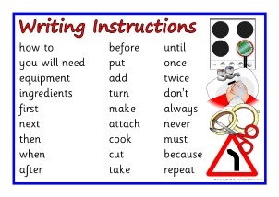 | All about me!  Can you create a poster all about yourself so that I can learn a bit about you? You could include pictures and short sentences about what you like, dislike and your family.  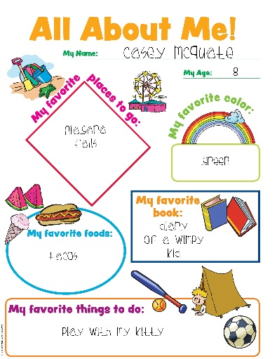
13.9.21 | Compare objects  Warm up – Which numbers are missing on the number track?  Challenge: Can you write any of these numbers in word form? |  | Queen Fact File  What can you find out about the Queen? (Queen Elizabeth II). Can you create a fact file to share what you have found out about her?  Oracy: Is the queen still important in England today? Do we need a royal family?  Sentence starters: I believe that the queen is still important because …  I agree with …… because …..  I disagree with …… because …  I would like to add that …
20.9.21 | More than and Less than - compare the numbers  Challenge: How many comparisons can you make using different numbers that you can think of? Can you use the more than and less than signs independently?  Oracy: Can you use the vocabulary ‘tens’ and ‘ones’ to explain how you know a number is greater or smaller than another? For example  “I know that 23 is greater than 13 because there is an extra ten.” |  | London Landmark Design  We have been looking at several London landmarks during our learning enquiry time including: The London Eye, Big Ben, Westminster Abbey, Buckingham Palace. Can you design and label a landmark of your own that you would add to London?
27.9.21 | Ordering numbers  Challenge: Can you spot my mistake when ordering these numbers from smallest to greatest?  5, 7, 9, 6, 10, 12 | Character Description  Imagine Paddington has gone missing, how would you describe him? Can you write some sentences along with a picture that could help someone to spot him?  Challenge: Can you add some adjectives that will blow me away? These are describing words such as brown, fluffy, dark blue, friendly etc. | Bear mask  We’ve been learning about bears in class. Can you create your own bear mask?  Challenge: Find out three facts about bears to tell us in class!
4.10.21 | Ordinal numbers  Watch the video and have a go at the activities on BBC bitesize:  https://www.bbc.co.uk/bitesize/articles/zhw8d6f  Challenge: | Paddington on holiday!  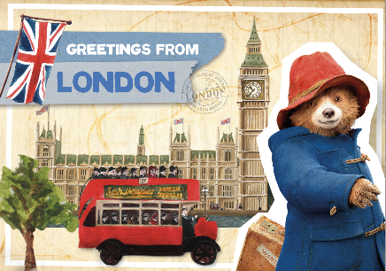  Paddington has been to London. Can you pretend that you are Paddington and write a post card to his family at home? What would he get up to in London? What would he see and do?  Challenge: With help from a grown up, you could find the landmarks that Paddington may visit on google maps. You could explore the area around them too! | Habitat Hunt  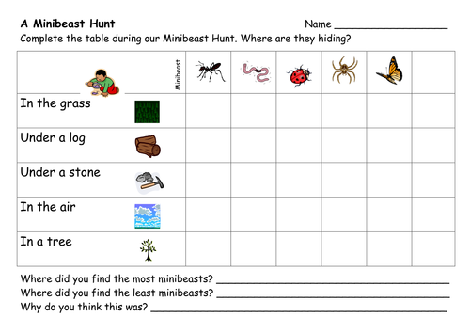  In science, we have been looking at habitats (the name of a place where a particular animal lives). Can you go on your own habitat hunt? You could look at where mini beasts live and see which habitat is the most popular!
11.10.21 | Number bonds to 10 and 20  Practice your number bonds to 10 using the game ‘hit the button’. https://www.topmarks.co.uk/maths-games/hit-the-button  When you are confident with these, try number bonds to 20.  Challenge: Can you write out any number fact families that you know will make 10 or 20. For example:  8 + 2 = 10  2 + 8 = 10  10 – 2 = 8  10 – 8 = 2 | Book review  Can you write a book review for our folder in the reading corner? You could choose a story that we have read in class recently together or a book that you enjoy from home! You could tell us:  - What the book is about  - Draw a picture of your favourite part  - How many stars you would give it when rating it.  Challenge: Is the book you chose fiction or non-fiction? Can you explain how you know? | Habitat box  Think of an animal and where it lives. Can you create a habitat for that animal? You could use a cardboard box and add what your animal needs to survive there. Challenge: You could add labels to the different parts of your habitat.  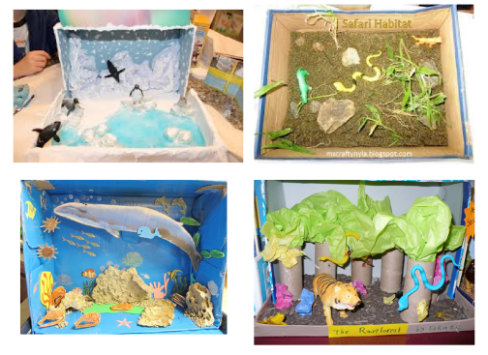  Oracy: Can you explain the important parts of that habitat for your animal to a grown up?
18.10.21 | 5 times tables  During this week and during half term, can you practice your 5 times tables? Try singing them, chanting them, quizzing them or writing them out if it helps.  Challenge: Try out times tables rockstars as a way of practicing your tables. Can you beat your best score? | Year 1 and 2 spelling word list  Choose between 5 and 10 of the year 1 and 2 spelling list (see blue box below) to learn how to spell. You could draw pictures to help you or have spelling quizzes with your family members to try to remember them!  Challenge: Can you write a sentence for each word you chose? | Teddy Bear Picnic  You could have your own teddy bears picnic with your favourite bears! Ask your grown up if you can make some treats that you can share during your picnic – this could include some baking or some marmalade sandwiches that Paddington would enjoy! Remember to read the scales for some real-life maths! We’d love to see what you get up to!  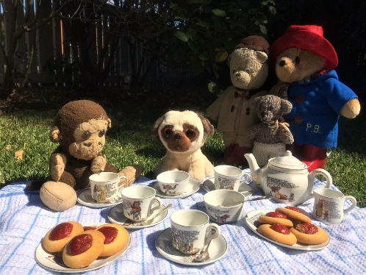

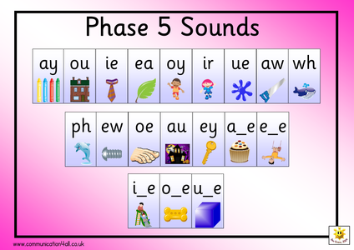
Are you able to read and spell the year 1 and 2 words? You could start practicing these. Please also make sure that you are reading at least 3 times a week.

