Applying & Analysing

Evaluating & Creating

**GEOGRAPHY:** Locating regions where the Mayans lived (relate to rainforests). Where in the world are these places in comparison to where we live?

**HOOK:** Watch the Horrible Histories film about the Mayans.

**GEOGRAPHY:** What would it be like to visit the rainforest? Planning a trip; what would they need? What would they do whilst in the rainforest?

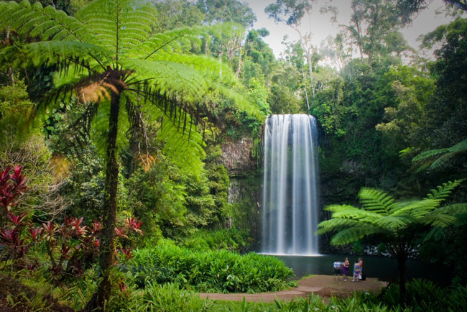

**GEOGRAPHY:** Compare a rainforest region with a region in Italy and a region in the UK – human and physical characteristics.

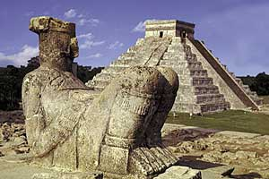

Science: To design their own animal and create a habitat for it to live in. Linked to D&T.

**ENGLISH: Invent – Jungle Survival, Survival at 40 degrees above, I am Cat and How the Whale became.**

**Science: Animals that live in the rainforest and their habitats. Compare to other habitats around the world.**

**Science: Look at the digestive and respiratory system of animals and humans.**

**ENGLISH: Innovate – Jungle Survival, Survival at 40 degrees above, I am Cat and How the Whale became.**

**Final event: To create a short play about Mayan life based on the style of Horrible Histories.**

**ART: How artists draw animals in motion**

**MATHS:**

**Units of measure**

**Pyramids/3D shapes**

**Methods of calculation**

**ENGLISH: Imitate – Jungle Survival, Survival at 40 degrees above, I am Cat and How the Whale became. Familiarisation – What do we know about animals and their habitats?**

**GEOGRAPHY:** Human impact the rainforest. What does the future hold for the rainforest?

**PE: Dance, Tennis, Gymnastics and Invasion games.**

[](http://www.google.co.uk/url?sa=i&rct=j&q=&esrc=s&source=images&cd=&cad=rja&uact=8&ved=0ahUKEwiRt_7b347KAhVH1RQKHfn2AngQjRwIBw&url=http://www.vanderbilt.edu/recreationandwellnesscenter/wellness/dance-class/&psig=AFQjCNFBhmb4Oa0_HuslrgkZRI7DOzpu3g&ust=1451948413651651)

**GEOGRAPHY: What is the rainforest like?**

**DISCREET**

COMPUTING: Weekly

**ART: Create drawings and sculpture of their own animal in movement.**

PE: (Tuesday and Wednesday Afternoon)

MFL: Weekly

**GEOGRAPHY: Locating and describing volcanoes and earthquakes**

**ART: Explore ways of showing movement in animals**

Remembering & Understanding