Autumn Term 1. Stoke Gabriel Primary School
Whole School Home Learning: Local Geography
This half term sees us all learning about our village locality and getting to grips with what ‘Geography’ is,
with each class having different field work tasks and skills to master, in line with the National Curriculum.
We have put together this Home Learning Chart to support the children’s learning over the half term.
It would be great if your child can complete the suggested activities for Challenge Level 1.
The children are invited to select additional tasks from Challenge levels 2 and 3, if they wish,
or they can develop their own ideas and projects along a similar theme – depending on their age.
The children can work independently, with their siblings, with a grandparent or parent, or with the whole family
– collaboration is of great value and siblings are welcome to produce a shared ‘outcome’ to bring in to school.
“I can think of few better ways to help young people become more knowledgeable, engaged with,
and perhaps respectful of, their local environments and communities than to get them studying their local area.”
Dr Rita Gardner, Director, Royal Geographical Society (with IBG).
Useful Resources:
- http://www.quikmaps.com – This programme enables you to add symbols, text-boxes and lines to a Google Map and is, apparently, pretty simple to use - recommended by The Geographical Association.
- https://www.ordnancesurvey.co.uk/mapzone/ - Ordnance Survey Mapzone for children.
- www.google.com/maps - Enter your postcode and explore...
- http://digimapforschools.edina.ac.uk/whoIsUsing - Digimaps for Schools, with facility to print OS maps in A4 or A3.
- http://www.magic.gov.uk/MagicMap.aspx - Detailed digital maps of all rural areas of Great Britain. (You can print sections of maps from this website).

Due by | 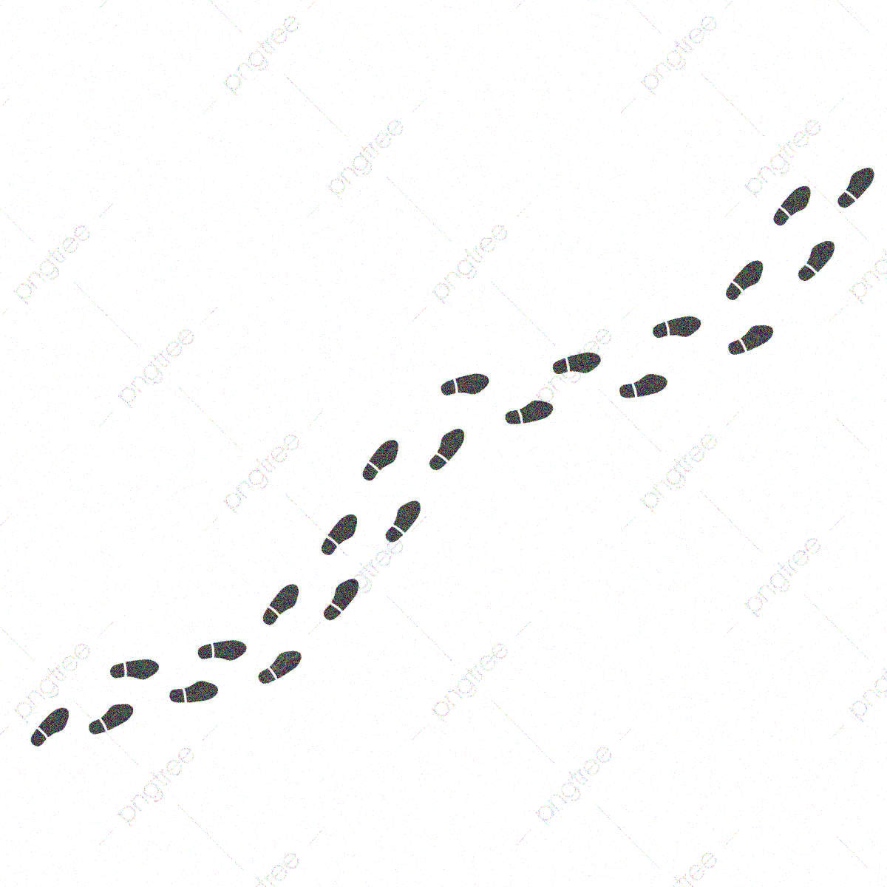  Monday 14th Sept | Monday 21st Sept | Monday 28th Sept | Monday 5th Oct | Monday 12th Oct | Monday 19th Oct
Focus | Where I live | My street | My local area | Maps and more | Wander & Ponder | Make
Challenge  Level 1 | 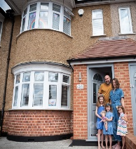  Ask a family member to take a photo of you in  front of the building you live in. Print it out and write your full name and your postal address. Can you learn your address? Alternatively, draw your building. | How many footsteps to the end of your road?  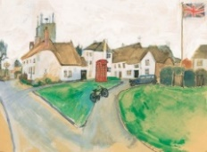  What types of buildings do you pass and what are they used for?  Show us your road: paint it, draw it, write about it - it’s up to you! | Locate your street on www.google.com/maps  [type postcode in].  What can you see nearby?  Are there lots of roads and buildings?  Some natural features?  List some of the key features that you spot.  Alternatively, use http://www.quikmaps.com and add text boxes. | 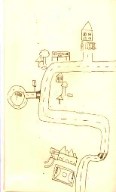  Explore beyond your street and make a record of your walk –  by drawing a simple map, or by making sound  recordings; by writing a description, or by making a Journey stick.  runwildmychild.com/journey-sticks/ | What do you like best about where you live?  Is there anything in your environment that you dislike?  Tell us: if you could change one thing, what would it be? Why?  How would your idea improve the area? | 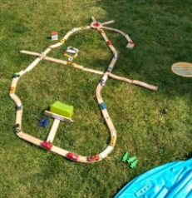  Use 3D materials to represent your local area: bricks,  Brio, Happy  Street, Lego,  paper, paint,  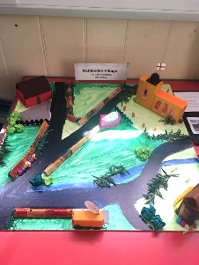  cardboard,  modelling clay..? It might be easier to bring photos  of your  model to  school!
Challenge  Level 2 | Create a Field Sketch of the building you live in and add labels.  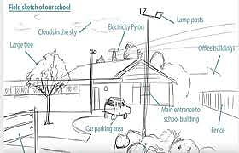  What type of home is it? A flat, terraced, semi-detached, bungalow, detached.  Do you know when it was built? Has it ever had a purpose other than being a home? | Make a collage of photos and drawings  to represent your street –zoom in on interesting details, e.g. human features, such as an old Post Box, or the road name, and natural features, such as an old oak tree, or a stream.  You might decide to feature front doors, or house names, chimneys, or gates, different surfaces under your feet, or wild flowers. What interests you? | Hand draw a map of your local area. Use symbols and add a key, like a real map. 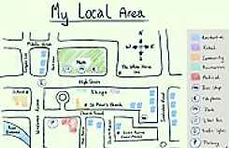  Use geographical vocabulary to write factual sentences, e.g.  ‘My brick bungalow is to the North of my school.’ ‘My local area is rural. It is a small village beside the River Dart in South Devon.’ | Explore your nearest town centre and gather info to write a report.  Notice the types of buildings and what are they used for – at street level and on the floors above.  Any green spaces?  Any ‘special’ buildings?  Find a place to sit and watch – make notes too. What do you notice about traffic, roads, parking, people, empty shops, behaviour due to Covid-19...? | Investigate your nearest ‘green’ space and make a labelled Field Sketch. 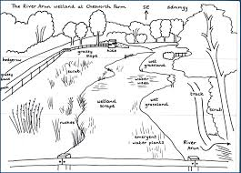  Visit on different days, or at different times of the day, and keep a record of how people use the space.  Does your data show any patterns?  Can you draw a graph? | Create a Digital map of your local area. 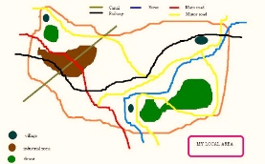  You could use the Paint App or similar on your computer or on a tablet. You can do it using a Word doc.  https://www.techwalla.com/articles/ how-to-draw-a-map-on-word  Alternatively, annotate a Google map on  http://www.quikmaps.com
Challenge Level 3 | By Monday 28th September: ‘ZOOM’  Watch ‘Zoom by Istvan Banyai’ on YouTube.  Make your own version of ‘Zoom’, based on your home, street, and local area. How could you achieve this? It doesn’t need to be a film – you could have comic-type page layouts, or lift-up flaps, or a series of images. Looking at Google Earth might be helpful – and Mrs Letten has a copy of the book |  |  | By Monday 19th October: ‘My Special Place’  Think about a local place that is special to you. Create a scrapbook-style page about this place, with handwritten thoughts, photos, art work, bark or sign rubbings, pressed flowers, a colour palette, a map, speech bubbles, a collection of words, an envelope containing ‘secrets’... or pop them all inside a decorated box. Be creative and celebrate ‘your’ special place!

