Dragonflies’ Home Learning – Autumn 2

Date | Phonics screening practice lists – Can you read these real and alien words?  Can you add the sound buttons? | Reading challenge – Sticker for each reading challenge completed when written in reading record. | Oracy task | Weekly
5th November | sprayed  played  holiday  yesterday  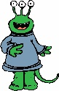  shray  kraying  phray  count  crouch  bounce  trousers  yound  bround  shrout | 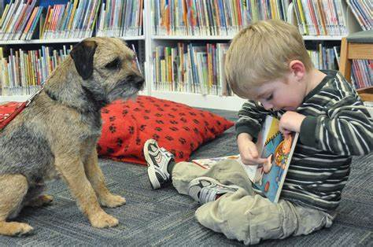  Read to a pet (if you have one!) If you don’t, can you read your book to your teddy? |  | Practice my spelling list  Times tables rockstars  Have I read to an adult 3 times?  Challenge: Can you read 5 times this week?
12th November | cried  tried  fried  spied  dried  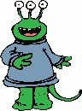  plieth  smiet  crief  cream  leaf  please  dream  season  pream  sleam  neamth | 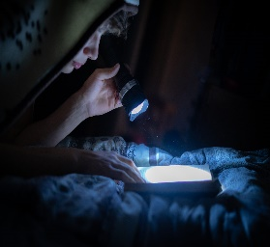  Read your book under your covers with a torch. |  | Practice my spelling list  Times tables rockstars  Have I read to an adult 3 times?  Challenge: Can you explain your favourite moment in the story and why?
19th November | enjoy  destroy  oyster  annoyed  throyed  smoythed  phroym  shirt  birthday  first  third  thirth  mirt  clird | 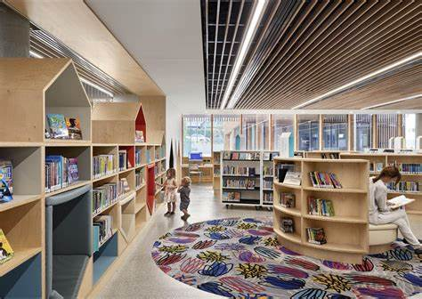  Read an extra book from the library this week! |  | Practice my spelling list  Times tables rockstars  Have I read to an adult 3 times?
26th November | clue  true  blue  tissue  argue  rescue  minue  shinue  thrue  flawless  prawn  squawk  awful  smawk  trawp  thrawm | 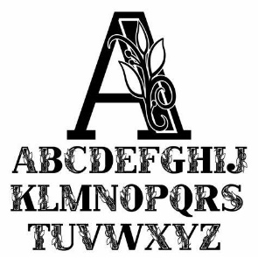  Read a book that was written by an author with the same initials as you. |  | Practice my spelling list  Times tables rockstars  Have I read to an adult 3 times?
3rd December | whisk  whistle  whale  whisper  wheat  whomper  whant  whelf  phone  dolphin  phonics  nephew  phantom  phallow  phont  maphin | Read a book that teaches you a new skill eg. Cook book or magic trick book. |  | Practice my spelling list  Times tables rockstars  Have I read to an adult 3 times?
10th December | drew  screw  blew  preview  cashew  minew  siplew  finew  aloe  Joe  toes  mistletoe  ploes  soen  croem | Read a magazine as an extra piece of reading this week. | Challenge: Can you and your adult come to an agreement on three top items?  Sentence stems:  I would take …. Because …  I agree because …  I respectfully disagree because …  Discuss: If you had 5 minutes to leave your house forever, what would you take with you? | Practice my spelling list  Times tables rockstars  Have I read to an adult 3 times?
17th December | August  haunting  fraud  applaud  auction  smaut  thaum  plaust  monkey  donkey  journey  honey  chimney  crumey  sluntey  shurley | Read a book whilst enjoying a warm bath – mind you don’t drop it!  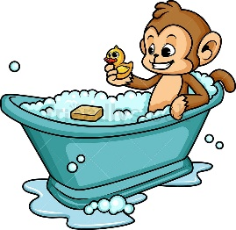 | Discuss: If you had all the money in the world, what would you do?  Sentence stems:  I would …. Because …  I love that idea because …  I disagree because … | Practice my spelling list  Times tables rockstars  Have I read to an adult 3 times?

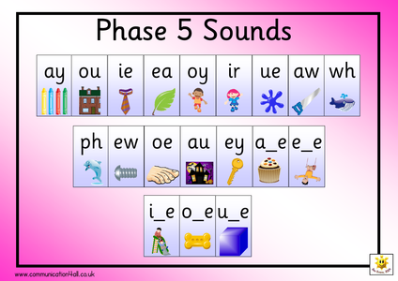
This half term’s learning enquiry task:
Use an ipad or phone at home (with your adult/ adult’s permission) to record your own news report about the Great Fire of London. Use everything that you have found out so far to report the facts about what happened as if you were there witnessing it.
Challenge: Can you use up-levelled adjectives to describe the Great Fire? What can you see, smell, taste, hear, feel?
This half term’s writing task:
Can you keep a diary like Samuel Pepys?
You could write about your weekends or what you get up to after school each day for a week.

Challenge: Can you use conjunctions to extend your sentences?
because so that if but and also however until

